Answer Quiz Chapter 2

1. If dprop. < L/R then there will be a collision because while one node is transmitting it also receive a packet from the other node too.
2. The mac address space is 48 bit. IPv4 address space is 32 bit. IPv6 address space is 128 bit.
3. ARP query sent within a broadcast frame because in other to send an ip datagram from one device to another it need to know both the ip address and the mac address of the receiver device. In order to get an unknown mac address of the receiver device it need to do an ARP query process as a broadcast message across a LAN.

ARP response sent within a frame with a specific destination MAC address because that specific Mac address is what the sender want to know when it do ARP query process.

2. 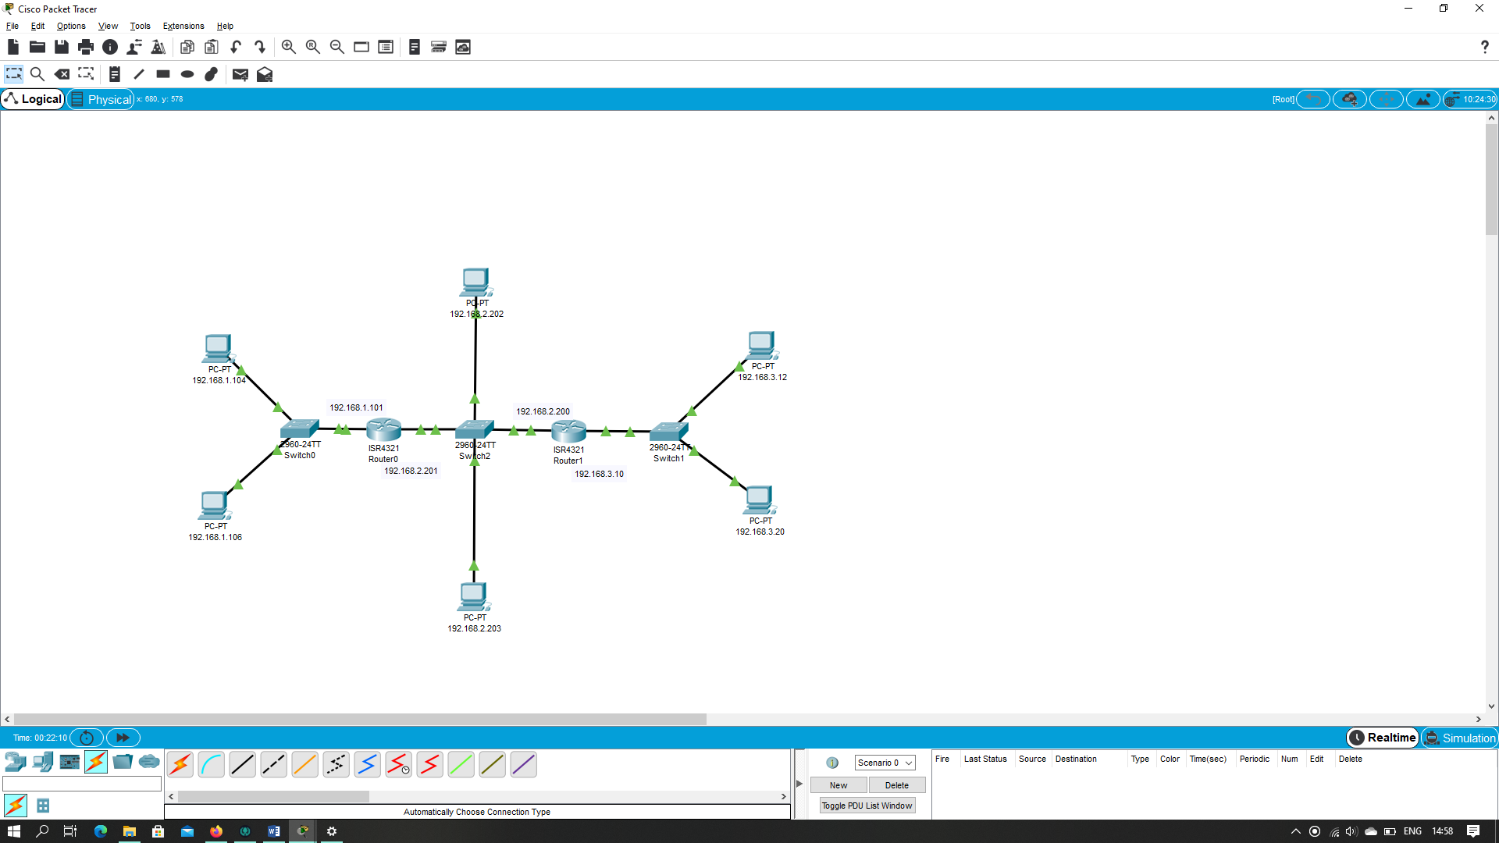 a. Assign IP addresses to all of the interfaces. For Subnet 1 use addresses of the form 192.168.1.xxx; for Subnet 2 uses addresses of the form 192.168.2.xxx; and for Subnet 3 use addresses of the form 192.168.3.xxx.

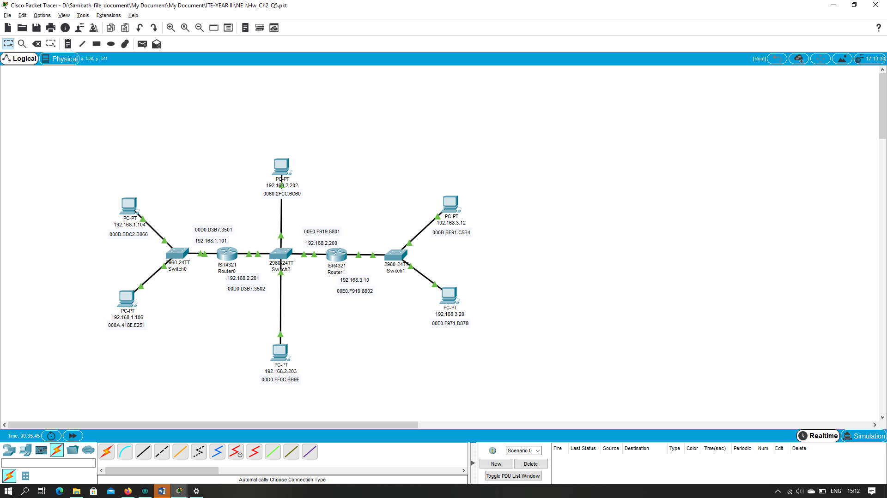b. Assign MAC addresses to all of the adapters :

c.

1. **Beacon frame** is one of the management frames in IEEE 802.11 based WLANs. It contains all the information about the network. Beacon frames are transmitted periodically, they serve to announce the presence of a wireless LAN and to synchronize the members of the service set. Beacon frames are transmitted by the AP in an infrastructure basic service set (BSS).
2. False. Because it is optional to use RTS / CTS protocol.
3. Acknowledgments used in 802.11 but not in wired Ethernet because send a packet through an Ethernet the device can sense a traffic across the cable and can assume if packet is sent successfully or not. But 802.11 need to have an acknowledgment because it has no idea If the packet is reach destination or not.
4. False.